|  |  |  |  |
| --- | --- | --- | --- |
| Version | Date | Details | Page Number |
| V1.0 | 04/17/2014 | Initial Draft |  |
| V1.1 | 04/24/2014 | 1. Changed the adv. Layout in landing page. 2. Mentioned the size of the advertisement space in the landing page. 3. Included an additional screenshot to depict the background advertisement in landing page. | 4&5 |

Howtube is the portal for people to look for “how to” videos and “DIY” (do it yourself) videos. This a first cut of requirements for initia development, we will be constantly refining the selection criteria as time progresses.

**1. Howtube.com Landing page:**

The HOWTUBE landing page is the first page of entry for the user. As a functionality it is divided into divided into 3 different sections.

**Section I:**

The first section of the howtube.com landing page will include the “Howtube” key word and the search box next to it. The Howtube link should always point to the home page.

A “categories” word at the top right corner with an arrow pointing downwards. The categories should not be a link. It is just directing the user to select one of the below categories for more refined search. [This space can also be used for any messaging in the future versions like partnership enrollment etc.]

The categories should be listed right below the search bar. The following categories need to be included. The catagories need to be a hyperlink.

* Food
* HEALTH
* Money& Business
* Parenting
* Tech
* Beauty
* Diy
* Relationships
* Sports

The below screen shot reflects the look and feel of this particular section.



**Section II**

The second section should contain the “Latest how to videos” released today, the search string will be “How to”.

Latest how to video’s should be pulled from youtube.com using the below filters. Please note that the selection criteria applied below is “today” and “high definition”. The rest are all default search selection options. You can also sort by “View count” to pull the popular ones first. The filter crieteria is shown below.

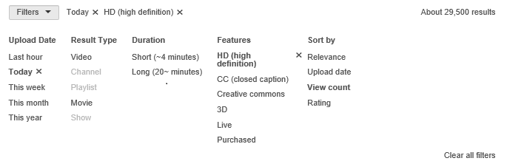

[Please note that at this point we intend to bring only HD videos as the quality of the content seems to be good of the sample collected. There is also large enough HD content]

The result set video should be running in the horizontal scroll from right to left. The initial screen should have 5 videos and then the next new video should appear at the right most space as the videos scroll from right to left.

The Screen for latest videos should be as depicted below:

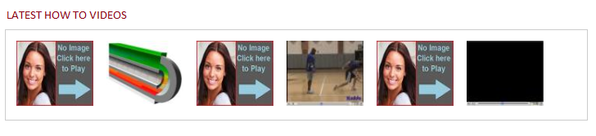

**SECTION III**

The third section should include interesting videos from each category. The videos should keep updating as the customer scrolls down. (Please refer to pinterest.com for reference, they do it for images and we want to do it for videos).

The idea behind the scrolling videos is to engage the customer who is just browsing and did not come to our site for any specific purpose. He would stumble upon something interesting as long as we have a choice of videos displayed in the landing page.

Each row will contain 5 videos except the first row. The first row will have space on the left for advertisement.

One new video from each category should appear in serial order for the customer scrolling through the landing page.

Every video will be pulled from youtube.com and the search criteria will be string “how to Followed by [Category name]. For the DIY category along, do not use the “how to” in the search string. It should be just DIY.

The selection criteria in each category will be video will be and “HD” and the sort criteria will be “view count”.

The below diagram shows an approximation of how it should look like.

The Text and the owner you see below each video should be replaced by Category name that the video belongs to. The idea behind displaying the category is that when a user likes the video he knows which category to go to see similar videos like the one he just saw.

The below advertisement space should be 300*250 inches space.

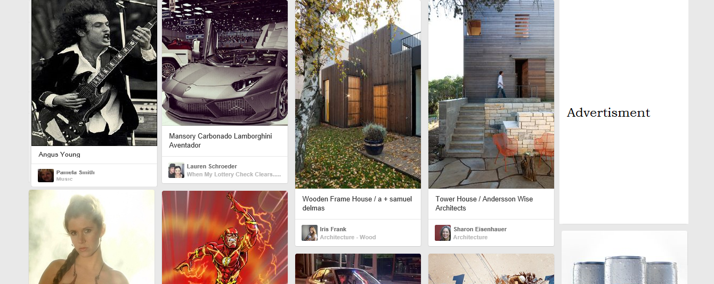

The below diagram depicts the background advertisement space.

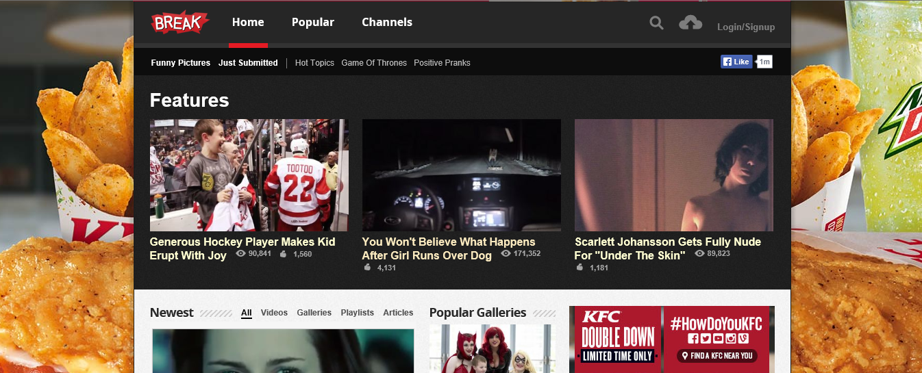

**2. Howtube category landing page:**

The Howtube category landing page will be exactly similar to the Howtube landing page except section I and the videos content.

The section I will look something like this. The food is not a link it is just a static word. This will show the user he is browsing the food category.



The section II and section III should be exactly similar to the Howtube landing page, but the videos displayed will be only related to food. The selection criteria will be the same but “how to food” will be the default string.

When the user comes to this screen and uses the search he will always be directed to the sub-category food search. Meaning “food” will be a default search selection in this screen plus the additional string the user enters will display the resultant set in the search result screen.

**2. Howtube.com search result screen:**

The search criteria should be HD and the sort criteria should be “view count” and “upload date”.

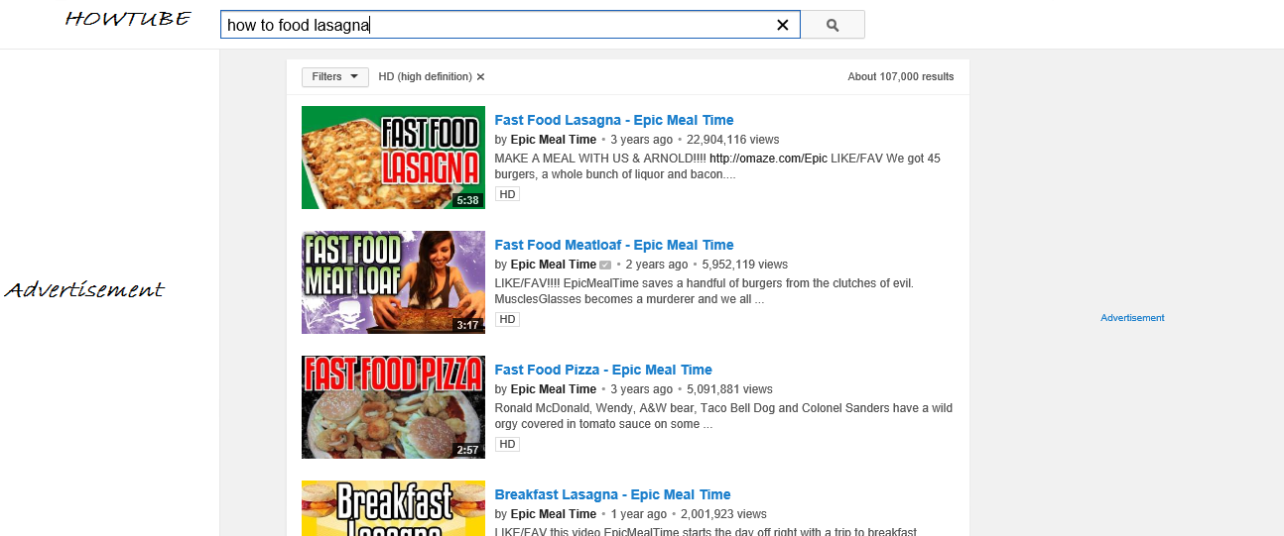

**3.** **Howtube.com video play page:**

Every video link on the landing page should be directed to the video play page. Once the video is selected from the landing page a new resource should be opened. The left margin of the page will be advertisement space as depicted below. The right side of the margin should be a list of related videos in the same category. The “HOWTUBE” link should connect back to the home page.

